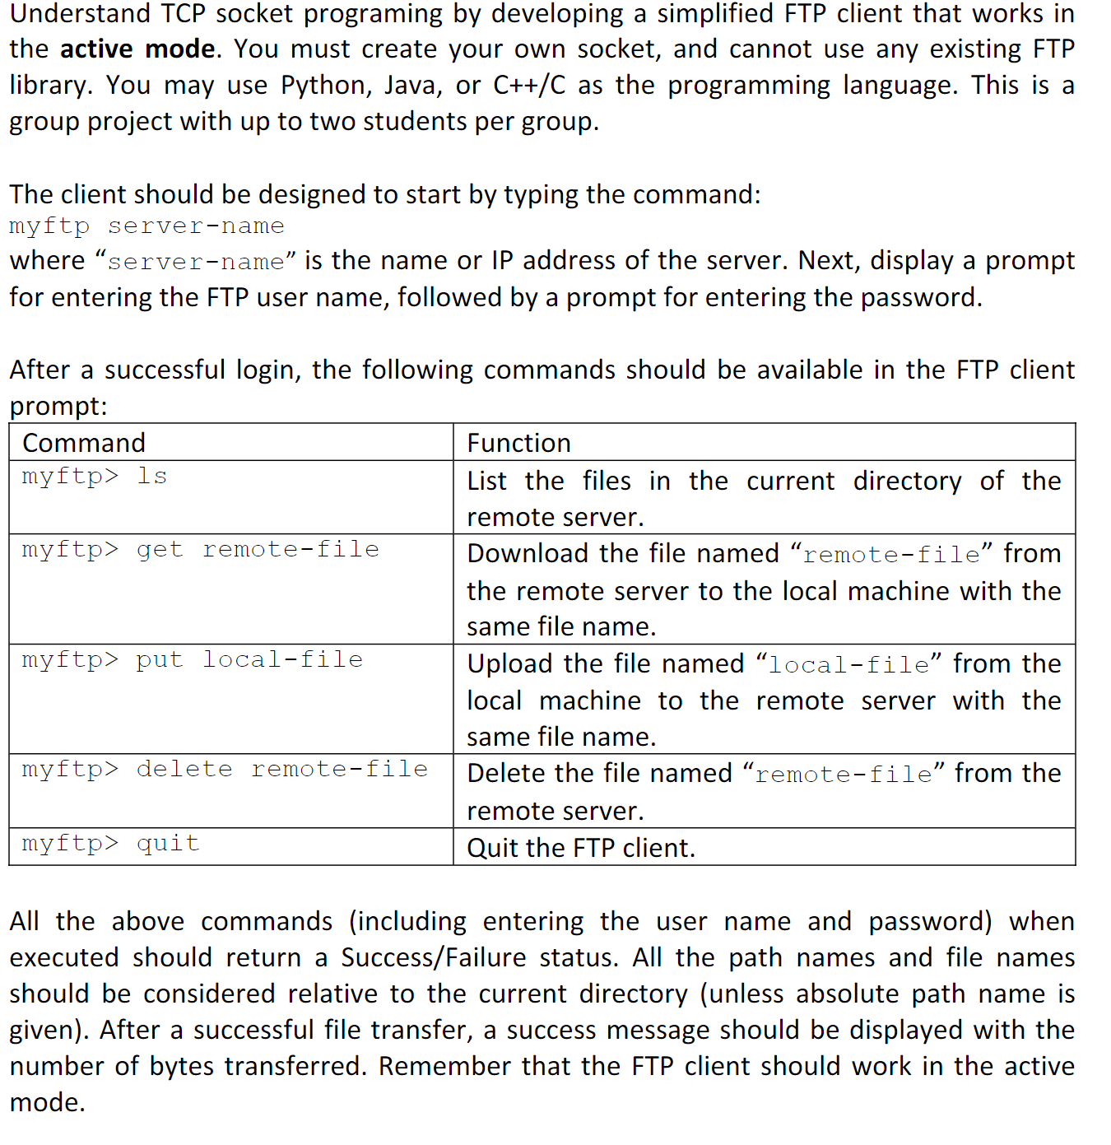

Understand TCP socket programing by developing a simplified FTP client that works in the active mode. You must create your own socket, and cannot use any existing FTP library. You may use Python, Java, or C++/Cas the programming language.

The client should be designed to start by typing the command: myftp server-name where “server-name” is the name or IP address of the server. Next, display a prompt for entering the FTP username, followed by a prompt for entering the password.

After a successful login, the following commands should be available in the FTP clientprompt:

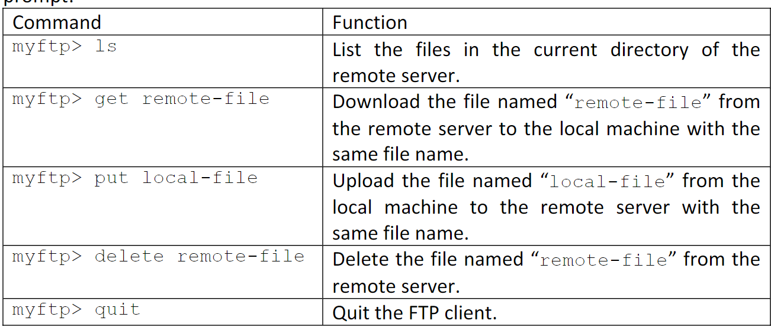

All the above commands (including entering the user name and password) when executed should return a Success/Failure status. All the path names and file names should be considered relative to the current directory (unless absolute path name is given). After a successful file transfer, a success message should be displayed with the number of bytes transferred. Remember that the FTP client should work in the active mode.

Please run the Windows/Linux/Mac OS built-­‐in command line FTP client to see the expected result of each command. You may test your client by connecting it to any standard FTP server,

Reference :

FTP RFC,

http://www.ietf.org/rfc/rfc959.txt

Test your client by connecting it to any standard FTP server.

Submit readme.txt and source code files. Please include compiling and running instructions.

Plagiarism will be reported. So be genuine and honest.